CSIS 112 Lab 2: Rectangle Class

Sean DeBarr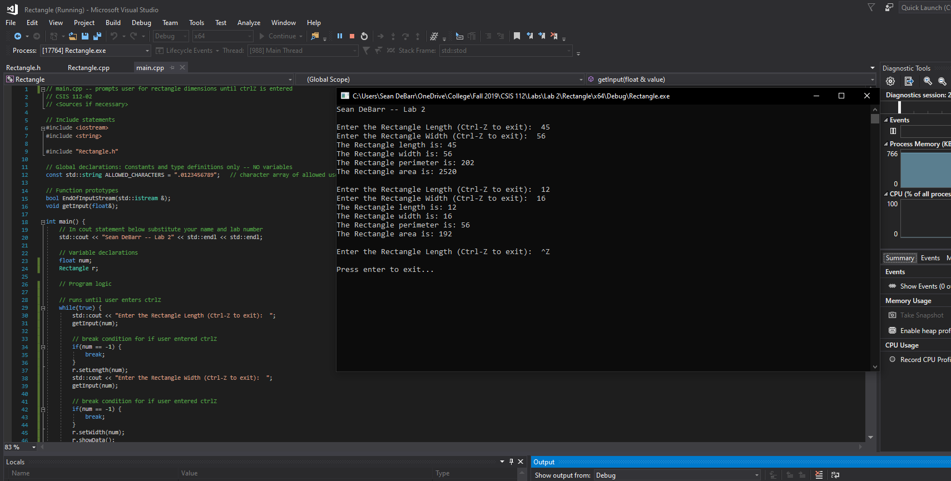

* 1. *I have not shared the source code in my program with anyone other than my instructor’s approved human sources.*
  2. *I have not used source code obtained from another student, or any other unauthorized source, either modified or unmodified.*
  3. *If any source code or documentation used in my program was obtained from another source, such as a text book or course notes, that has been clearly noted with a proper citation in the comments of my program.*
  4. *I have not knowingly designed this program in such a way as to defeat or interfere with the normal operation of any machine it is graded on or to produce apparently correct results when in fact it does not.*